**BY Sadhik Bhatia**

**Of Ramjas, Delhi University**

**Roll Number: 2024/12/073**

**Course: BSc Mathematics Honours**

**Subject: Digital Marketing, Unit 1**

**Marketing in the Digital World**

# **Learning Objectives**

1. Understand the fundamental concepts of digital marketing and its significance in the modern business landscape.

2. Differentiate between traditional marketing and digital marketing methodologies, recognizing their unique strengths and weaknesses.

3. Explore the various digital marketing channels available, including SEO, social media, and content marketing, and understand how to utilize them effectively.

4. Learn about search engine optimization (SEO) and its critical role in enhancing online visibility and driving traffic to websites.

5. Understand the strategies behind search advertising and how to effectively leverage pay-per-click (PPC) campaigns to achieve marketing goals.

6. Analyze the components of display advertising and its effectiveness in building brand awareness and reaching targeted audiences.

7. Gain insights into social media marketing, including the creation of engaging content and strategies for community engagement.

8. Discover affiliate marketing and email marketing as effective tools for nurturing leads and driving conversions.

9. Understand the importance of content marketing and how to create valuable content that resonates with target audiences.

10. Familiarize yourself with mobile marketing strategies, understanding how to reach consumers on their devices.

# **Index**

1. Introduction to Digital Marketing..................................................... Page 4

2. Understanding Digital Marketing...................................................... Page 6

3. Features of Digital Marketing........................................................... Page 8

4. Difference Between Traditional and Digital Marketing.................... Page 9

5. Transitioning from Traditional to Digital Marketing...................... Page 10

6. Primary Digital Marketing Channels............................................... Page 11

7. Other Digital Marketing Channels.................................................. Page 13

8. The Customer Value Journey.......................................................... Page 14

9. Digital Marketing Trends……........................................................ Page 15

10. Measuring Digital Marketing Success........................................... Page 17

11. Creating Effective Marketing Strategies....................................... Page 18

12. Social Marketing Strategies........................................................... Page 19

13. Email Marketing Strategies........................................................... Page 21

14. Content Marketing Strategies…………….................................... Page 23

15. Search Engine Optimization.......................................................... Page 24

CONCLUSION………………………………………………………Page 26

LEARNING OUTCOMES…………………..………………………Page 27

REFERENCES………………………………………………………Page 28

# **1. Introduction to Digital Marketing**

Digital marketing is the process of promoting and selling products or services using online marketing strategies, such as social media marketing, search marketing, and email marketing. It refers to the promotion of brands to connect with potential customers using the internet and other forms of digital communication. This includes not only email, social media, and web-based advertising, but also text and multimedia messages as a marketing channel.

The key to digital marketing is that it requires the use of digital technologies and platforms to reach customers. In a world where over half of the global population is connected to the internet, digital marketing has become an essential tool for businesses looking to increase their reach and engage with consumers on a deeper level. Its relevance has dramatically increased with the rise of smartphones, tablets, and laptops, which provide constant connectivity.

## The Evolution of Marketing to the Digital Age

The marketing landscape has undergone a massive transformation over the past few decades. In the early days of marketing, businesses focused on direct, personal interactions and advertising through traditional means such as print media, radio, and television. However, with the advent of the internet and the rise of digital technologies, marketing has evolved into a more data-driven and automated process.

Today, businesses can use a variety of digital platforms and technologies to reach their target audience. From social media platforms like Facebook and Instagram to search engines like Google, the opportunities for engaging with potential customers have multiplied. These platforms allow for more personalized and targeted marketing efforts, as businesses can gather vast amounts of data on customer behavior and preferences.

As a result, digital marketing offers a level of flexibility and precision that traditional marketing methods cannot. For instance, marketers can segment audiences based on factors such as age, location, interests, and online behavior, tailoring their messages to resonate with specific groups. This has led to the development of highly sophisticated marketing strategies that can be quickly adapted based on real-time feedback and performance metrics.

## The Rise of Digital Marketing

The growth of the internet has played a significant role in the rise of digital marketing. With billions of users connected to the web, businesses now have the opportunity to interact with consumers 24/7. The ability to engage with customers in real time has revolutionized how brands communicate their messages and build relationships with their audience.

Digital marketing is more than just placing ads online. It encompasses a wide range of strategies, including search engine optimization (SEO), content marketing, social media marketing, pay-per-click (PPC) advertising, email marketing, and more. These strategies work together to create a cohesive marketing plan that reaches consumers at every stage of the buying process.

## Key Advantages of Digital Marketing

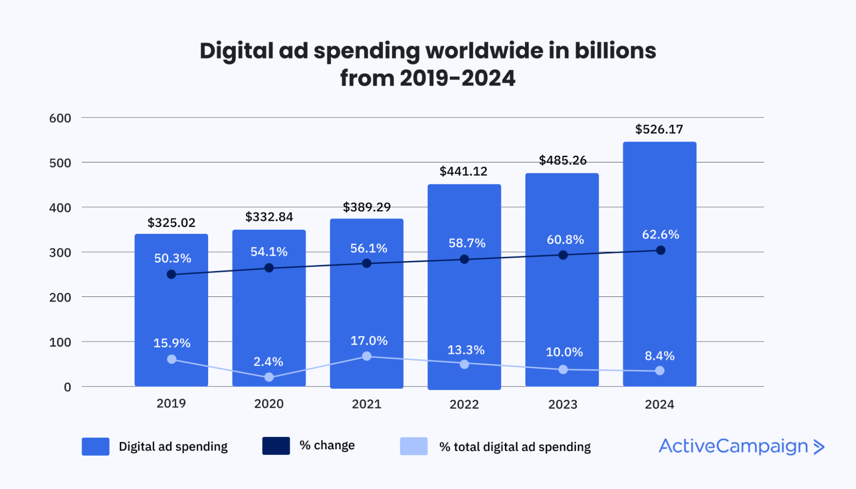1. Cost-Effective: Digital marketing is often more cost-effective than traditional marketing methods. Small businesses, in particular, can leverage digital channels to reach their target audience without the need for large marketing budgets.  
2. Targeted: Digital marketing allows businesses to target specific demographics, making it easier to reach the right audience with the right message.  
3. Measurable: One of the biggest advantages of digital marketing is its measurability. With the right tools in place, businesses can track the performance of their campaigns in real time, allowing them to adjust their strategies based on data-driven insights.  
4. Global Reach: Unlike traditional marketing, which is often limited by geography, digital marketing allows businesses to reach a global audience. This opens up new opportunities for growth and expansion.  
5. Personalization: Digital marketing allows for highly personalized marketing efforts, as businesses can gather data on their customers' preferences, behaviors, and interactions with their brand.

*Graph 1: Growth of Digital Marketing Spend Over the Years*

Placeholder for a graph illustrating the rise in digital marketing spend across various sectors.

*Flow Chart 1: The Digital Marketing Process*

This flow chart will illustrate the process of digital marketing from content creation to customer engagement and analysis.

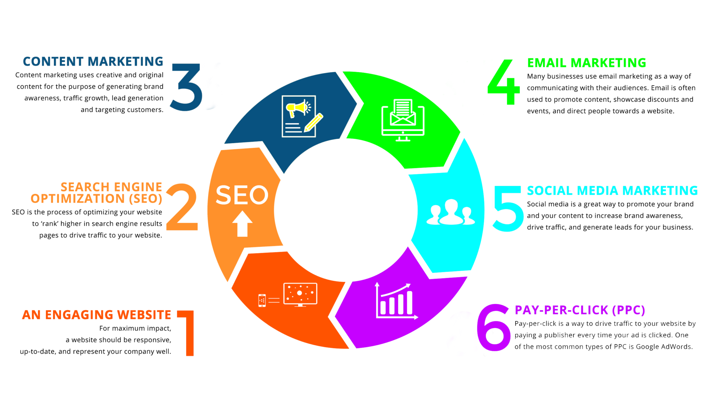

Digitalized marketing is dynamic and ever-evolving, with new trends emerging regularly. Companies must stay ahead of these trends to remain competitive. With the right strategies and tools in place, digital marketing can provide a significant return on investment (ROI) by reaching the right people at the right time. These advantages make digital marketing an indispensable tool in today's competitive business environment. By using a combination of strategies, businesses can build a strong online presence, engage with their audience, and ultimately drive growth.

# **2. Understanding Digital Marketing**

Digital marketing, at its core, refers to the marketing of products and services through digital technologies, primarily the internet, but also including mobile phones, display advertising, and any other digital medium. It is an umbrella term that encompasses a range of marketing activities that leverage digital channels to communicate with consumers.

One of the critical aspects of digital marketing is the data-driven approach it takes. Unlike traditional marketing, which relies heavily on assumptions and broad messaging, digital marketing allows for precise targeting based on data collected from online interactions. This means that businesses can tailor their marketing efforts to specific groups of people who are more likely to be interested in their products or services.

## Key Elements of Digital Marketing

Digital marketing is comprised of various components, each playing a distinct role in the overall marketing strategy. The following are some of the core elements of digital marketing:

1. Search Engine Optimization (SEO): SEO is the practice of optimizing websites and online content to improve their visibility in search engine results. A well-executed SEO strategy can help businesses attract organic (unpaid) traffic to their website, making it a highly valuable component of digital marketing.  
2. Content Marketing: Content marketing focuses on creating and distributing valuable, relevant, and consistent content to attract and engage a specific audience. This can include blog posts, videos, infographics, and social media content.  
3. Social Media Marketing: This involves promoting products or services on social media platforms like Facebook, Instagram, Twitter, and LinkedIn. Social media marketing allows businesses to interact with their customers directly, build brand loyalty, and drive traffic to their website.  
4. Email Marketing: One of the most effective forms of direct marketing, email marketing involves sending targeted messages to potential customers. It is highly personalized and allows for direct communication with customers.  
5. Pay-Per-Click (PPC) Advertising: PPC advertising involves paying for ads to appear on search engines, social media, or other digital platforms. Businesses only pay when users click on the ads, making it a cost-effective way to drive traffic.

## The Role of Data in Digital Marketing

Data is at the heart of digital marketing. Every online interaction provides businesses with valuable insights into consumer behavior. By analyzing this data, companies can fine-tune their marketing efforts to better meet the needs and preferences of their audience.

For example, social media platforms provide detailed analytics on user engagement, allowing businesses to understand which posts are resonating with their audience. Similarly, email marketing tools can track open rates and click-through rates, providing insight into which messages are most effective.

This data-driven approach allows for continuous optimization. Digital marketers can use real-time data to adjust their campaigns, ensuring they are always improving and maximizing return on investment (ROI).

## Digital Marketing Strategy

A successful digital marketing strategy is not just about implementing various marketing tactics; it is about creating a cohesive plan that ties all these elements together. Businesses need to ensure that their digital marketing efforts align with their overall business objectives and are targeted at the right audience.

The first step in developing a digital marketing strategy is to define clear goals. Whether the goal is to increase brand awareness, generate leads, or drive sales, each marketing tactic should be designed to support these objectives.

Next, businesses need to identify their target audience. Digital marketing offers a unique opportunity to segment audiences based on demographic information, interests, and online behavior. By understanding who they are trying to reach, businesses can tailor their messaging and ensure it resonates with the right people.

Finally, businesses must continuously monitor and adjust their strategy. The digital landscape is constantly changing, with new trends, technologies, and consumer behaviors emerging regularly. By staying flexible and using data to inform decisions, businesses can stay ahead of the competition and achieve long-term success in digital marketing.

*Table 1: Key Components of a Digital Marketing Strategy*

|  |  |
| --- | --- |
| Component | Description |
| SEO | Optimizing content to rank higher in search engines. |
| Content Marketing | Creating valuable content to engage the target audience. |
| Social Media Marketing | Using social platforms to promote products or services. |
| PPC Advertising | Paid advertising to drive traffic to the website. |

# **3. Features of Digital Marketing**

Digital marketing is characterized by several unique features that set it apart from traditional marketing approaches. These features have allowed businesses to engage with customers in more personalized and efficient ways. In this section, we will explore some of the most significant features of digital marketing that contribute to its growing popularity.

## 1. Interactivity

One of the most significant features of digital marketing is its interactive nature. Unlike traditional marketing, which primarily involves one-way communication, digital marketing enables two-way communication between businesses and their customers.

## 2. Real-Time Results

Another major advantage of digital marketing is the ability to obtain real-time results. Through analytics tools, marketers can track and measure the performance of their campaigns in real time, allowing them to make adjustments as needed. This immediate feedback loop is a powerful tool for optimizing marketing strategies and improving return on investment (ROI).

## 3. Global Reach

Digital marketing allows businesses to reach a global audience. Unlike traditional marketing methods, which are often limited by geography, digital marketing can be conducted from anywhere and reach customers around the world. This global reach opens up opportunities for businesses to expand into new markets and grow their customer base beyond physical borders.

## 4. Measurability and Analytics

One of the most defining features of digital marketing is its measurability. Marketers can track key metrics such as website traffic, engagement rates, conversion rates, and customer demographics. These analytics provide valuable insights into the effectiveness of marketing campaigns, allowing businesses to fine-tune their strategies.

## 5. Cost-Effectiveness

Compared to traditional marketing, digital marketing is often more cost-effective. Small businesses, in particular, can benefit from digital marketing’s ability to reach a large audience without needing a massive budget. For instance, businesses can run social media campaigns or pay-per-click (PPC) ads with a relatively low investment and still achieve a significant reach.

## 6. Targeted and Personalized

Digital marketing allows for highly targeted and personalized marketing campaigns. Marketers can use data on customer demographics, preferences, and behavior to create tailored messages that resonate with specific groups of people. This level of personalization increases the likelihood of converting potential customers into paying customers.

## 7. Flexibility and Adaptability

Digital marketing campaigns are highly adaptable. Marketers can easily adjust their strategies based on performance data, allowing for greater flexibility compared to traditional marketing. For example, if a social media campaign is underperforming, marketers can quickly modify the content, targeting, or budget to improve results.

*Table 2: Comparing Digital Marketing and Traditional Marketing*

|  |  |  |
| --- | --- | --- |
| Feature | Digital Marketing | Traditional Marketing |
| Interactivity | Two-way communication (e.g., social media) | One-way communication (e.g., TV, radio) |
| Global Reach | Unlimited geographic reach | Limited by location |
| Cost-Effectiveness | Lower costs (e.g., social media, email) | Higher costs (e.g., print, TV) |
| Measurability | Highly measurable (e.g., analytics tools) | Difficult to measure (e.g., customer surveys) |
| Flexibility | Easily adjustable | Harder to change mid-campaign |

*Flow Chart 2: Features of Digital Marketing*

**Measurability & Analytics**

**Global Reach**

**Real Time Results**

**Interactivity**



This flow chart will visualize the different features of digital marketing, showing how each feature contributes to the overall effectiveness of a marketing campaign.

**Targeted & Personalized**



**Cost Effectiveness**

**Flexibility & Adaptability**

In summary, the unique features of digital marketing provide businesses with an unparalleled level of control, flexibility, and precision in their marketing efforts. By leveraging interactivity, real-time results, global reach, and the ability to target specific audiences, businesses can build more effective and engaging marketing campaigns.

# **4. Differences Between Traditional & Digital Marketing**

As businesses evolve in response to technological advancements and changing consumer behavior, the contrast between traditional and digital marketing becomes more apparent.

## 1. Communication Method

One of the most significant differences between traditional and digital marketing lies in the communication method. Traditional marketing primarily involves one-way communication.

## 2. Audience Targeting

Traditional marketing relies on broad audience targeting. Digital marketing, however, allows for precise audience targeting through the use of analytics and data. Marketers can segment their audience based on factors like age, location, interests, and online behavior, ensuring that their message reaches the people most likely to be interested in their product or service.

## 3. Cost and Budget

Traditional marketing campaigns, such as TV commercials or print ads, often require a large budget, making them more suitable for larger companies with substantial marketing funds. In contrast, digital marketing offers more affordable options, such as pay-per-click (PPC) advertising or social media campaigns, which allow smaller businesses to compete and reach a broad audience without overspending.

## 4. Measurement of Results

Measuring the effectiveness of traditional marketing campaigns can be challenging. Digital marketing, however, allows for precise tracking of performance metrics. Tools like Google Analytics, Facebook Insights, and email marketing platforms provide real-time data on key metrics such as engagement rates, click-through rates, and conversions.

## 5. Flexibility and Adaptability

Traditional marketing campaigns often require substantial time and financial resources to create, which means they are less flexible once they are launched. If a business wants to change a traditional marketing campaign mid-way, it usually requires additional expenses. Digital marketing, however, allows for quick adjustments

## 6. Global vs. Local Reach

Traditional marketing campaigns are often limited by geography. Digital marketing, on the other hand, provides businesses with global reach. Through online platforms, businesses can engage with audiences from around the world, breaking down the geographic barriers of traditional marketing.

*Table 3: Key Differences Between Traditional and Digital Marketing*

|  |  |  |
| --- | --- | --- |
| Aspect | Traditional Marketing | Digital Marketing |
| Communication | One-way (e.g., TV, radio) | Two-way (e.g., social media) |
| Audience Targeting | Broad, non-specific | Precise, data-driven |
| Cost | Expensive (e.g., print ads) | Cost-effective (e.g., PPC ads) |
| Measurement | Difficult to measure | Easily measurable |
| Flexibility | Less adaptable | Highly adaptable |

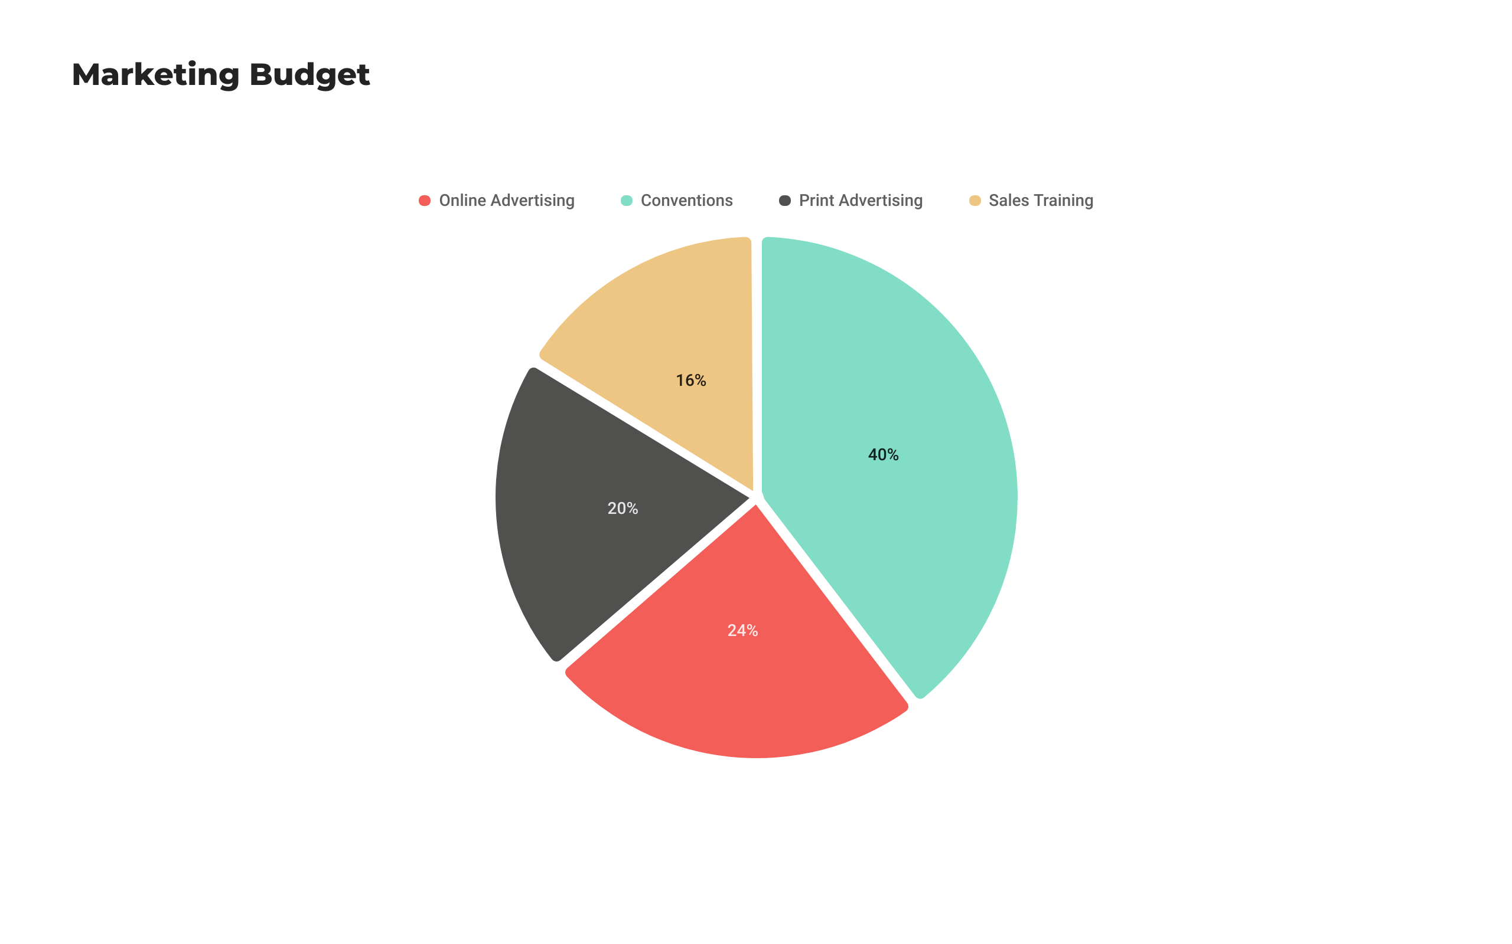*Pie Chart 1: Budget Allocation Between Traditional and Digital Marketing*

This pie chart will demonstrate how businesses typically allocate their marketing budget between traditional and digital channels. As businesses shift towards digital marketing, more of the budget is being allocated to online platforms.

In conclusion, while both traditional and digital marketing have their advantages, the flexibility, global reach, cost-effectiveness, and ability to measure results make digital marketing a more attractive option for many businesses. The next section will focus on how businesses can successfully transition from traditional to digital marketing.

# **5. Transitioning from Traditional to Digital Marketing**

The transition from traditional to digital marketing is an essential shift that many businesses must undergo to stay competitive in the digital age. While traditional marketing methods such as print advertising, television commercials, and direct mail still have their place, the increasing dominance of digital platforms has transformed the marketing landscape.

## 1. Evaluate Current Marketing Efforts

The first step in transitioning to digital marketing is to evaluate the effectiveness of current marketing strategies. Businesses need to assess how well their traditional marketing efforts have performed in terms of reach, engagement, and return on investment (ROI). This evaluation will help identify areas where digital marketing can offer improvements and provide a roadmap for integrating new tactics.

## 2. Understand the Target Audience

A key component of successful digital marketing is a deep understanding of the target audience. Digital marketing allows businesses to gather more precise data about their audience than traditional marketing methods. Through analytics tools, businesses can segment their audience based on demographics, online behavior, and preferences. Understanding the target audience’s online habits will help businesses tailor their digital marketing strategies to reach them more effectively.

## 3. Invest in Digital Marketing Channels

Once a business has evaluated its current marketing efforts and understands its target audience, the next step is to invest in appropriate digital marketing channels. These channels may include search engine optimization (SEO), pay-per-click (PPC) advertising, social media marketing, email marketing, and content marketing. The key is to select the channels that align with the business's goals and where its target audience is most active.

## 4. Develop a Digital Marketing Strategy

A successful transition to digital marketing requires a well-thought-out strategy. This strategy should outline the business’s objectives, the digital marketing channels that will be utilized, and the key performance indicators (KPIs) that will measure success. Digital marketing strategies should be flexible and adaptable, allowing for continuous improvement based on real-time data and performance analytics.

## 5. Overcoming Challenges

While transitioning from traditional to digital marketing offers many benefits, businesses may encounter several challenges. One common challenge is the learning curve associated with digital tools and platforms. Businesses that are accustomed to traditional marketing methods may need to invest time and resources in training their marketing teams to effectively use digital tools like Google Analytics, social media platforms, and email marketing software.

Another challenge is the need for constant adaptation. Digital marketing is fast-paced and continuously evolving, which means businesses must stay updated with the latest trends, algorithms, and technologies. However, businesses that are willing to embrace these challenges can reap the rewards of increased engagement, better targeting, and higher ROI.

Table 4: Investment in Various Digital Marketing Channels

|  |  |  |
| --- | --- | --- |
| Digital Marketing Channel | Average Investment (Annual) | ROI Potential |
| Search Engine Optimization (SEO) | $5,000 - $30,000 | High (Organic, long-term) |
| Pay-Per-Click (PPC) Advertising | $10,000 - $50,000 | Moderate (Immediate results) |
| Social Media Marketing | $3,000 - $20,000 | High (Engagement-based) |
| Email Marketing | $2,000 - $10,000 | High (Cost-effective, targeted) |

In conclusion, businesses must recognize that transitioning to digital marketing is not a one-size-fits-all process. The approach should be tailored to the specific needs of the business, its industry, and its target audience. By investing in the right channels and developing a flexible digital marketing strategy, businesses can successfully make the transition and gain a competitive advantage in the digital world.

# **6. Digital Marketing Channels**

Digital marketing relies on a variety of channels to engage with customers and achieve marketing goals. Each channel has its unique strengths and can be used to target different aspects of the customer journey.

## 1. Search Engine Optimization (SEO)

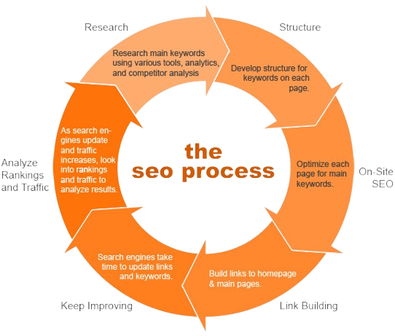Search Engine Optimization (SEO) is the process of optimizing a website to rank higher in search engine results pages (SERPs) for specific keywords. It involves both on-page and off-page techniques to improve a site's visibility to search engines like Google.

SEO can be broken down into two main categories:   
- On-Page SEO: This involves optimizing the content and structure of the website itself, including keyword usage, meta tags, and internal linking.   
- Off-Page SEO: This includes external factors such as backlinks from other websites, social media activity, and overall online presence.

*Flow Chart 4: SEO Process*

The flow chart visualizes the SEO process, illustrating how businesses can optimize their website content, structure, and online presence to achieve higher search engine rankings.

## 2. Pay-Per-Click (PPC) Advertising

Pay-Per-Click (PPC) advertising is a digital marketing model where businesses pay a fee each time one of their ads is clicked. Unlike SEO, which aims to drive organic traffic, PPC focuses on driving paid traffic by placing ads on search engines or social media platforms. The most popular PPC platform is Google Ads, but businesses can also use social media platforms like Facebook and Instagram for PPC campaigns.

The main benefit of PPC advertising is its ability to deliver immediate results. However, it can be more costly than SEO in the long.

*Table 5: Comparison of SEO and PPC*

|  |  |  |
| --- | --- | --- |
| Aspect | SEO | PPC |
| Traffic Type | Organic | Paid |
| Cost | Free | Pay per click |

## 3. Social Media Marketing

Social media marketing involves promoting products or services through social media platforms like Facebook, Twitter, Instagram, and LinkedIn. It allows businesses to engage with their target audience, build brand awareness, and foster customer loyalty.

One of the major benefits of social media marketing is its potential for virality. Content that resonates with users can be shared widely, leading to increased brand visibility. Additionally, social media platforms offer detailed targeting options, allowing businesses to reach specific audiences based on demographics, interests, and behaviors.

This flow chart illustrates the process of social media marketing, from content creation to audience engagement and post-campaign analysis.

## 4. Email Marketing

Email marketing is one of the most cost-effective digital marketing channels. It involves sending personalized messages to a targeted group of subscribers to promote products, share news, or nurture leads. Email marketing can be used for a variety of purposes, including newsletters, promotional campaigns, and customer retention.

The success of email marketing campaigns depends on factors such as the quality of the email list, the relevance of the content, and the timing of the emails. Automation tools such as Mailchimp and Constant Contact make it easier for businesses to manage their email campaigns and track their performance.

*Table 6: Comparison of Social Media Marketing and Email Marketing*

|  |  |  |
| --- | --- | --- |
| Aspect | Social Media Marketing | Email Marketing |
| Reach | Wide, but less targeted | Highly targeted (subscribers) |
| Engagement | High potential for virality | Personalized, direct |

In conclusion, each digital marketing channel offers unique opportunities and challenges. Businesses should carefully evaluate their goals, target audience, and budget to determine which channels will be most effective for them. A multi-channel strategy that integrates SEO, PPC, social media, and email marketing can yield the best results in the digital world

# **7. Other Digital Marketing Channels**

In addition to the well-known digital marketing channels discussed previously, there are several other channels that play a crucial role in a comprehensive digital marketing strategy. These include affiliate marketing, content marketing, and mobile marketing. In this section, we will explore these channels, their benefits, and effective strategies for implementation.

## 1. Affiliate Marketing

Affiliate marketing is a performance-based marketing model where businesses reward affiliates (partners) for driving traffic or sales to their website through the affiliate's marketing efforts. Affiliates promote the products or services of a business, and they earn a commission for each sale or lead generated through their unique referral links.

The key benefits of affiliate marketing include:   
- **Cost-Effectiveness**: Businesses only pay for successful transactions, making it a low-risk marketing strategy.  
**- Extended Reach**: Affiliates can help businesses reach new audiences and markets.  
- **Performance-Based Model:** Affiliates are incentivized to drive high-quality traffic, leading to better conversion rates.

## 2. Content Marketing

Content marketing is a strategic approach focused on creating and distributing valuable, relevant content to attract and engage a target audience. The primary goal is to drive profitable customer action by providing content that educates, entertains, or informs.

Effective content marketing involves various types of content, including:   
- **Blog Posts:** Articles that provide valuable insights or solutions to audience pain points.  
- **Infographics:** Visual content that summarizes complex information in an easily digestible format.  
- **Videos:** Engaging video content that captures attention and can be shared across platforms.  
**- E-books and Whitepapers**: In-depth resources that showcase expertise and provide valuable information.

*Table 8: Benefits of Content Marketing*

|  |  |
| --- | --- |
| Benefit | Description |
| Brand Awareness | Creates awareness of the brand and its offerings. |
| Customer Engagement | Encourages interaction and builds relationships with customers. |
| Lead Generation | Attracts potential customers and nurtures them through the sales funnel. |

## 3. Mobile Marketing

Mobile marketing refers to digital marketing strategies aimed at reaching consumers on their mobile devices, including smartphones and tablets. With the growing use of mobile devices for browsing and shopping, mobile marketing has become an essential component of a successful digital marketing strategy.

Key strategies for mobile marketing include:   
**- Responsive Design:** Ensuring websites and content are optimized for mobile devices.  
**- SMS Marketing:** Sending targeted promotions and notifications via text messages.  
**- Mobile Apps:** Developing applications that enhance user experience and engagement with the brand.  
**- Location-Based Marketing:** Utilizing GPS technology to send targeted promotions to customers based on their location.

## 4. Integrating Other Channels

Integrating affiliate marketing, content marketing, and mobile marketing into a cohesive digital marketing strategy is essential for maximizing reach and effectiveness. By leveraging these channels in conjunction with other digital marketing efforts, businesses can create a comprehensive approach that resonates with their target audience.

For example, a business could use content marketing to create informative blog posts that educate consumers about their products. These posts could include affiliate links to drive sales while being optimized for mobile devices to ensure accessibility.

In conclusion, other digital marketing channels, such as affiliate marketing, content marketing, and mobile marketing, play a vital role in a comprehensive marketing strategy. By understanding and effectively utilizing these channels, businesses can enhance their reach, engage their audience, and ultimately drive sales.

# **8. The Customer Value Journey**

The Customer Value Journey (CVJ) is a framework that outlines the stages customers go through when interacting with a brand. Understanding this journey is crucial for businesses to effectively engage their audience and provide value at each stage.

The CVJ can be broken down into several key stages: Awareness, Engagement, Subscription, Conversion, Excitement, Ascension, Advocacy, and Promotion. Each stage presents unique opportunities for businesses to connect with customers and guide them towards becoming loyal advocates.

## 1. Awareness

In the Awareness stage, potential customers become aware of a brand's existence. This can occur through various channels, including social media, search engine results, and word of mouth. At this stage, businesses should focus on creating compelling content that captures attention and generates interest.

## 2. Engagement

Once awareness is established, the next step is Engagement. Here, customers interact with the brand through content, social media, or other channels. Effective engagement strategies include providing valuable information, answering questions, and encouraging discussions. The goal is to deepen the connection with potential customers and keep them interested.

## 3. Subscription

The Subscription stage involves converting engaged customers into subscribers. This can be achieved by offering valuable resources, such as newsletters, e-books, or exclusive content, in exchange for their contact information. Businesses should emphasize the benefits of subscribing to encourage sign-ups.

## 4. Conversion

Conversion occurs when subscribers make their first purchase. This stage is critical, as it represents a significant milestone in the customer journey. To optimize conversions, businesses should ensure a seamless buying experience, provide clear calls to action, and offer incentives such as discounts or free trials.

## 5. Excitement

After the initial purchase, businesses must focus on creating a sense of Excitement. This involves ensuring that customers are satisfied with their purchase and feel valued. Strategies to enhance excitement include personalized follow-up communications, customer appreciation initiatives, and loyalty programs.

## 6. Ascension

The Ascension stage refers to encouraging customers to make repeat purchases or upgrade to higher-value products or services. Businesses can implement upselling and cross-selling strategies, as well as loyalty programs that reward repeat customers. Providing exceptional customer service during this stage is also crucial for building long-term relationships.

## 7. Advocacy

In the Advocacy stage, satisfied customers become brand advocates, promoting the business to their friends, family, and social networks. Encouraging customers to share their experiences through testimonials, reviews, and referrals can significantly enhance brand credibility and reach.

## 8. Promotion

Finally, the Promotion stage involves leveraging brand advocates to promote the business actively. This can be achieved through referral programs, affiliate marketing, and social sharing campaigns. By incentivizing customers to promote the brand, businesses can tap into new audiences and drive further growth.

Understanding the Customer Value Journey is essential for businesses looking to enhance their marketing strategies. By mapping out each stage and implementing targeted strategies, businesses can optimize their customer engagement and build lasting relationships.

## The Ozone 03 Concept Key

The Ozone 03 Concept Key represents a framework that highlights the essential elements of a successful digital marketing strategy. It emphasizes the importance of focusing on the customer at every stage of the journey and adapting marketing efforts to meet their evolving needs.

In conclusion, the Customer Value Journey provides valuable insights into how customers interact with a brand and the strategies businesses can implement to enhance engagement at each stage. By understanding this journey, businesses can create more effective marketing campaigns and foster customer loyalty.

# **9. Digital Marketing Trends**

In the rapidly evolving world of digital marketing, staying abreast of the latest trends is essential for businesses looking to maintain a competitive edge. This section explores some of the most significant digital marketing trends currently shaping the industry, including artificial intelligence (AI), personalization, voice search, and video marketing.

## 1. Artificial Intelligence (AI)

Artificial Intelligence is revolutionizing digital marketing by enabling businesses to analyze data more effectively and automate marketing processes. AI technologies, such as machine learning and natural language processing, help marketers gain insights into customer behavior, predict trends, and optimize campaigns.

Key applications of AI in digital marketing include:   
**- Chatbots:** Automated customer service tools that provide instant responses to customer inquiries, enhancing user experience.  
**- Predictive Analytics:** Tools that analyze historical data to predict future customer behavior and trends, helping businesses make informed decisions.  
**- Personalized Recommendations:** AI algorithms analyze user behavior to provide tailored product recommendations, increasing conversion rates.

## 2. Personalization

Personalization involves tailoring marketing messages and experiences to individual customers based on their preferences, behaviors, and demographics. With the rise of big data and analytics, businesses can deliver more relevant content and offers, significantly improving customer engagement and satisfaction.

Effective personalization strategies include:   
**- Dynamic Content:** Adjusting website content based on user behavior and preferences to enhance relevance.  
**- Email Personalization:** Crafting personalized email campaigns that address the specific needs and interests of recipients.  
**- Retargeting Ads:** Displaying ads to users who have previously interacted with a brand, reminding them of products they may be interested in.

*Table 10: Personalization Techniques*

|  |  |
| --- | --- |
| Technique | Description |
| Dynamic Content | Content that adapts based on user behavior. |
| Retargeting Ads | Ads displayed to previous visitors of a website. |

## 3. Voice Search Optimization

With the growing use of voice-activated devices, such as smartphones and smart speakers, voice search is becoming increasingly popular. Optimizing for voice search requires a different approach compared to traditional search engine optimization (SEO).

## 4. Video Marketing

Video marketing continues to gain traction as an effective medium for engaging customers and conveying messages. With the popularity of platforms like YouTube, and Instagram Reels, businesses can leverage video content to connect with their audience on a deeper level.

## 5. Conclusion on Digital Marketing Trends

In conclusion, understanding and adapting to the latest digital marketing trends is essential for businesses looking to thrive in a competitive landscape. By leveraging AI, personalization, voice search optimization, and video marketing, businesses can enhance their marketing strategies and connect more effectively with their audience.

# **10. Measuring Digital Marketing Success**

Measuring the success of digital marketing campaigns is crucial for understanding what works and what doesn't. By tracking key performance indicators (KPIs) and other relevant metrics, businesses can make data-driven decisions to optimize their marketing strategies.

## 1. Key Performance Indicators (KPIs)

Key Performance Indicators (KPIs) are measurable values that demonstrate how effectively a company is achieving its key business objectives. For digital marketing, some essential KPIs include:

- Website Traffic: The number of visitors to a website, which indicates the effectiveness of marketing efforts in driving traffic.

- Conversion Rate: The percentage of visitors who complete a desired action, such as making a purchase or signing up for a newsletter. A higher conversion rate indicates effective marketing and website optimization.

- Customer Acquisition Cost (CAC): The total cost of acquiring a new customer, including marketing and sales expenses. Reducing CAC while increasing customer lifetime value is crucial for profitability.

- Return on Investment (ROI): A measure of the profitability of marketing efforts, calculated by comparing the revenue generated to the cost of the campaign.

*Table 11: Key Performance Indicators*

|  |  |
| --- | --- |
| KPI | Description |
| Website Traffic | Number of visitors to the site. |
| Conversion Rate | Percentage of visitors completing a desired action. |
| Customer Acquisition Cost (CAC) | Total cost of acquiring a new customer. |
| Return on Investment (ROI) | Profitability measure for marketing efforts. |

## 2. Web Analytics Tools

Web analytics tools play a vital role in tracking and analyzing digital marketing metrics. Some popular tools include:

- Google Analytics: A comprehensive tool that provides insights into website traffic, user behavior, and conversion tracking. It helps businesses understand how visitors interact with their site.

- Google Search Console: A tool that helps businesses monitor their website's presence in Google search results. It provides data on search traffic, performance, and indexing issues.

- Social Media Analytics: Each social media platform offers analytics tools that track engagement, reach, and audience demographics, allowing businesses to measure the success of their social media campaigns.

## 3. Importance of A/B Testing

A/B testing, also known as split testing, is a method of comparing two versions of a webpage or marketing asset to determine which one performs better. By testing different elements, such as headlines, images, and calls to action, businesses can optimize their marketing efforts for better results.

Key benefits of A/B testing include:

- Data-Driven Decisions: A/B testing provides empirical evidence on what works, helping marketers make informed decisions.

- Increased Conversion Rates: By identifying and implementing the most effective elements, businesses can significantly improve their conversion rates.

- Enhanced User Experience: A/B testing allows businesses to refine their website and marketing materials to better meet customer needs.

## 4. Conclusion on Measuring Success

In conclusion, measuring digital marketing success is essential for businesses to understand their performance and optimize their strategies. By tracking key performance indicators, utilizing web analytics tools, and implementing A/B testing, businesses can gain valuable insights that drive continuous improvement.

# **11. Creating Effective Content Marketing Strategies**

Content marketing is a strategic approach focused on creating and distributing valuable, relevant content to attract and engage a clearly defined audience. The ultimate goal is to drive profitable customer action. In this section, we will explore how to develop an effective content marketing strategy.

## 1. Define Your Goals

The first step in creating an effective content marketing strategy is to define clear, measurable goals. These goals should align with your overall business objectives and provide direction for your content efforts. Common content marketing goals include:

- Brand Awareness: Increasing visibility and recognition of your brand among target audiences.

- Lead Generation: Attracting potential customers and nurturing them through the sales funnel.

- Customer Engagement: Building relationships with customers through valuable content that resonates with them.

- Sales and Conversions: Driving revenue by encouraging potential customers to make purchases or take desired actions.

*Table 12: Common Content Marketing Goals*

|  |  |
| --- | --- |
| Goal | Description |
| Brand Awareness | Increasing visibility and recognition. |
| Lead Generation | Attracting potential customers. |
| Customer Engagement | Building relationships with customers. |
| Sales and Conversions | Driving revenue and encouraging purchases. |

## 2. Understand Your Audience

Understanding your target audience is crucial for creating content that resonates with them. Conducting thorough audience research will help you identify their needs, preferences, and pain points. Key steps include:

- Creating Buyer Personas: Develop detailed profiles of your ideal customers, including demographics, interests, and behaviors.

- Conducting Surveys and Interviews: Gather feedback from existing customers to understand their preferences and expectations.

- Analyzing Competitor Content: Study the content strategies of competitors to identify gaps and opportunities.

## 3. Content Planning and Creation

Once you understand your audience, it's time to plan and create valuable content. A successful content marketing strategy includes a variety of content types, such as:

- Blog Posts: Informative articles that address customer pain points and provide solutions.

- Videos: Engaging visual content that demonstrates products or shares valuable information.

- Infographics: Visually appealing representations of data or information that simplify complex topics.

- Podcasts: Audio content that allows customers to consume information on the go.

## 4. Content Distribution and Promotion

Creating great content is only part of the equation; you must also distribute and promote it effectively. Key strategies include:

- Social Media Sharing: Utilize social media platforms to share content and engage with your audience.

- Email Marketing: Distribute content through email newsletters to keep your audience informed and engaged.

- Influencer Partnerships: Collaborate with influencers to reach wider audiences and enhance credibility.

## 5. Measure and Optimize

To ensure your content marketing strategy is effective, regularly measure and optimize your content's performance. Key metrics to track include:

- Engagement Rates: Likes, shares, and comments on your content.

- Website Traffic: The number of visitors to your content pages.

- Conversion Rates: The percentage of users who take desired actions after consuming your content.

## 6. Conclusion on Content Marketing Strategies

In conclusion, developing an effective content marketing strategy requires clear goals, an understanding of your audience, and a well-planned content creation and distribution process. By measuring and optimizing your content, businesses can enhance their marketing efforts and achieve better results.

# **12. Social Media Marketing Strategies**

Social media marketing is the process of creating and sharing content on social media platforms to achieve marketing and branding goals. With billions of users globally, social media offers a unique opportunity for businesses to connect with their audience, build brand loyalty, and drive sales. In this section, we will explore effective social media marketing strategies.

## 1. Choosing the Right Platforms

Not all social media platforms are suitable for every business. It's essential to choose the right platforms based on your target audience and marketing goals. Key platforms include:

- Facebook: Ideal for businesses targeting a broad audience, offering various ad formats and engagement opportunities.

- Instagram: Focuses on visual content and is popular among younger demographics, making it perfect for brands in fashion, beauty, and lifestyle.

- Twitter: A platform for real-time engagement and updates, great for brands that want to participate in conversations and trends.

- LinkedIn: Best for B2B marketing, allowing businesses to connect with professionals and industry leaders.

*Table 13: Social Media Platforms Overview*

|  |  |
| --- | --- |
| Platform | Ideal For |
| Facebook | Broad audience engagement. |
| Instagram | Visual storytelling. |
| Twitter | Real-time engagement. |
| LinkedIn | B2B marketing. |

## 2. Creating Engaging Content

Creating content that resonates with your audience is crucial for social media marketing success. Strategies for creating engaging content include:

- Visual Content: Use images, videos, and infographics to capture attention and increase engagement.

- User-Generated Content: Encourage your audience to share their experiences with your brand, enhancing authenticity.

- Storytelling: Share stories that resonate with your audience, connecting them emotionally to your brand.

- Interactive Content: Use polls, quizzes, and live videos to encourage participation and engagement.

## 3. Building a community

Building a community around your brand is essential for fostering customer loyalty and advocacy. Strategies for community building include:

- Engagement: Respond promptly to comments and messages, showing your audience that you value their input.

- Consistent Posting: Maintain a regular posting schedule to keep your audience engaged and informed.

- Hosting Events: Organize webinars, Q&A sessions, or live events to connect with your audience and foster relationships.

*Table 14: Community-Building Strategies*

|  |  |
| --- | --- |
| Strategy | Description |
| Engagement | Responding to audience interactions. |
| Consistent Posting | Regular updates to keep audience engaged. |
| Hosting Events | Connecting through webinars and live sessions. |

## 4. Analyzing Performance

To determine the effectiveness of your social media marketing efforts, it's essential to analyze performance metrics. Key metrics to track include:

- Engagement Rate: The level of interaction (likes, shares, comments) your content receives.

- Reach and Impressions: The number of unique users who see your content and the total number of times your content is displayed.

- Follower Growth: The increase in your audience size over time, indicating the effectiveness of your marketing efforts.

## 5. Conclusion on Social Media Marketing

In conclusion, developing effective social media marketing strategies involves choosing the right platforms, creating engaging content, building a community, and analyzing performance metrics. By implementing these strategies, businesses can enhance their online presence and foster meaningful relationships with their audience.

# **13. Email Marketing Strategies**

Email marketing is a powerful tool that enables businesses to communicate directly with their audience, promote their products, and build relationships with customers. Despite the rise of social media and other digital channels, email remains one of the most effective marketing methods for driving conversions and maintaining customer engagement. In this section, we will explore effective strategies for email marketing that can help businesses maximize their reach and effectiveness.

## 1. Building an Email List

The success of an email marketing campaign largely depends on the quality of the email list. A robust email list consists of subscribers who have opted in to receive communications from your business. To build an effective email list, consider the following strategies:

- Opt-in Forms: Use clear and concise opt-in forms on your website, landing pages, and social media to encourage users to subscribe.

- Lead Magnets: Offer valuable content such as eBooks, whitepapers, or discounts in exchange for email sign-ups.

- Segmenting Your Audience: Organize your email list into segments based on customer preferences and behaviors for more targeted messaging.

*Table 17: Email List Building Strategies Overview*

|  |  |
| --- | --- |
| Strategy | Description |
| Opt-in Forms | Encouraging subscriptions through clear forms. |
| Lead Magnets | Offering incentives for email sign-ups. |
| Segmenting Your Audience | Organizing lists for targeted messaging. |

## 2. Crafting Compelling Emails

Once you have built your email list, the next step is to create compelling emails that resonate with your audience. Key elements to consider when crafting emails include:

- Subject Lines: Write engaging subject lines that grab attention and encourage opens. A/B testing different subject lines can help identify what works best.

- Personalization: Use personalization techniques, such as addressing subscribers by name and tailoring content based on their preferences.

- Clear Call to Action (CTA): Each email should have a clear CTA that guides readers on what to do next, whether it’s to make a purchase or read a blog post.

Flow Chart 16: Email Crafting Process

This flowchart outlines the steps for crafting effective emails, including subject lines, personalization, and CTAs.

## 3. Automating Email Campaigns

Automation is a vital component of email marketing, allowing businesses to send targeted messages at optimal times without manual effort. Key benefits of automation include:

- Drip Campaigns: Set up automated email sequences that nurture leads over time, delivering relevant content based on user actions.

- Behavioral Triggers: Use automation tools to send emails triggered by user behavior, such as abandoned cart reminders or re-engagement campaigns.

- Personalized Recommendations: Automate personalized product recommendations based on previous purchases or browsing behavior.

*Table 18: Benefits of Email Automation Overview*

|  |  |
| --- | --- |
| Benefit | Description |
| Drip Campaigns | Nurturing leads through automated email sequences. |
| Behavioral Triggers | Emails triggered by specific user actions. |
| Personalized Recommendations | Automated product suggestions based on user behavior. |

## 4. Measuring Email Marketing Success

To optimize email marketing efforts, it’s crucial to measure the success of campaigns using key performance indicators (KPIs). Important metrics to track include:

- Open Rate: The percentage of recipients who opened your email. A high open rate indicates effective subject lines.

- Click-Through Rate (CTR): The percentage of recipients who clicked on links within your email. This measures engagement and effectiveness of CTAs.

- Conversion Rate: The percentage of recipients who completed a desired action, such as making a purchase. This is the ultimate measure of campaign success.

Graph 15: Key Email Marketing Metrics

This graph illustrates key metrics to track in email marketing, including open rates, CTR, and conversion rates.

## 5. Conclusion on Email Marketing Strategies

In conclusion, email marketing remains a highly effective strategy for reaching and engaging customers. By building a quality email list, crafting compelling emails, automating campaigns, and measuring success, businesses can harness the full potential of email marketing.

# **14. Content Marketing Strategies**

Content marketing is a strategic approach focused on creating and distributing valuable, relevant content to attract and engage a target audience. The goal is to drive profitable customer action while building brand loyalty and authority. In this section, we will explore effective content marketing strategies that can enhance online visibility and customer engagement.

## 1. Understanding Your Audience

The foundation of effective content marketing is a deep understanding of your target audience. Knowing their needs, preferences, and pain points allows you to create content that resonates with them. Strategies for understanding your audience include:

- Creating Buyer Personas: Develop detailed profiles of your ideal customers to tailor content that meets their specific needs.

- Conducting Surveys and Interviews: Engage with your audience directly to gather insights about their interests and preferences.

- Analyzing Competitors: Study your competitors’ content strategies to identify gaps and opportunities in your own approach.

*Table 19: Strategies for Understanding Your Audience*

|  |  |
| --- | --- |
| Strategy | Description |
| Creating Buyer Personas | Developing profiles for ideal customers. |
| Conducting Surveys and Interviews | Gathering direct insights from your audience. |
| Analyzing Competitors | Identifying gaps in competitors' content strategies. |

## 2. Creating Valuable Content

Creating high-quality, valuable content is essential for engaging your audience and establishing your brand as an authority in your industry. Consider the following content types:

- Blog Posts: Regularly publishing informative and relevant blog posts helps drive traffic and improve SEO.

- Infographics: Visual content, such as infographics, can effectively convey complex information and capture audience attention.

- Videos: Video content is highly engaging and can enhance understanding of your products or services.

## 3. Promoting Your Content

Creating great content is only half the battle; promotion is crucial to ensure it reaches your target audience. Effective promotion strategies include:

- Social Media Sharing: Share your content on social media platforms to reach a broader audience and encourage engagement.

- Email Marketing: Leverage your email list to distribute valuable content directly to your subscribers.

- Influencer Partnerships: Collaborate with influencers in your industry to promote your content and reach their followers.

*Table 20: Strategies for Promoting Your Content*

|  |  |
| --- | --- |
| Promotion Strategy | Description |
| Social Media Sharing | Expanding reach through social platforms. |
| Email Marketing | Direct distribution to subscribers. |
| Influencer Partnerships | Leveraging influencer audiences. |

## 4. Measuring Content Marketing Effectiveness

To ensure your content marketing efforts are paying off, it's essential to track and measure effectiveness using key performance indicators (KPIs). Some important metrics to consider include:

- Website Traffic: Monitor the number of visitors to your website to assess the reach of your content.

- Engagement Metrics: Track likes, shares, and comments to gauge how well your content resonates with your audience.

- Lead Generation: Measure the number of leads generated from your content marketing efforts to determine ROI.

## 5. Conclusion on Content Marketing Strategies

In conclusion, content marketing is a vital component of any digital marketing strategy. By understanding your audience, creating valuable content, promoting effectively, and measuring success, businesses can leverage content marketing to achieve their goals.

# **15. Search Engine Optimization (SEO)**

Search Engine Optimization (SEO) is the process of optimizing a website to improve its visibility on search engine results pages (SERPs). The primary objective of SEO is to drive organic traffic to a website by enhancing its ranking for relevant keywords. In this section, we will explore key SEO strategies and best practices.

## 1. Understanding SEO Basics

SEO involves various techniques and strategies that can help improve a website's ranking on search engines. Understanding the basic concepts of SEO is crucial for any digital marketing strategy.

- Keywords: Keywords are specific words or phrases that users enter into search engines. Effective SEO involves researching and integrating relevant keywords into your content.

- On-Page SEO: This includes optimizing elements on your website, such as meta tags, headings, and content, to improve search visibility.

- Off-Page SEO: This refers to actions taken outside of your website to impact your rankings, such as link building and social media engagement.

*Table 21: Key Concepts in SEO*

|  |  |
| --- | --- |
| SEO Concept | Description |
| Keywords | Words/phrases used in searches. |
| On-Page SEO | Optimizing website elements. |
| Off-Page SEO | Actions taken outside the website. |

## 2. Keyword Research Strategies

Keyword research is the process of identifying the terms and phrases that potential customers use when searching for products or services. Effective keyword research strategies include:

- Using Keyword Research Tools: Tools like Google Keyword Planner, SEMrush, and Ahrefs can help identify high-traffic keywords.

- Analyzing Competitors: Examine the keywords your competitors rank for to find new opportunities.

- Long-Tail Keywords: Focus on long-tail keywords, which are longer and more specific phrases that often have lower competition.

## 3. On-Page SEO Techniques

On-page SEO involves optimizing individual pages on your website to improve their rankings. Key techniques include:

- Title Tags: Ensure each page has a unique and descriptive title tag that includes the target keyword.

- Meta Descriptions: Write compelling meta descriptions that encourage clicks and include relevant keywords.

- Header Tags: Use header tags (H1, H2, H3) to structure your content and include keywords where appropriate.

- Internal Linking: Link to other relevant pages on your website to improve navigation and distribute page authority.

*Table 22: On-Page SEO Techniques*

|  |  |
| --- | --- |
| Technique | Description |
| Title Tags | Unique page titles with keywords. |
| Meta Descriptions | Compelling summaries with keywords. |
| Header Tags | Structured content with keywords. |
| Internal Linking | Links to relevant pages. |

## 4. Off-Page SEO Strategies

Off-page SEO focuses on actions taken outside of your website to improve its rankings. Important strategies include:

- Link Building: Acquire backlinks from reputable websites to increase authority and trust.

- Social Media Engagement: Promote content on social media to increase visibility and drive traffic.

- Online Reputation Management: Monitor and manage online reviews and mentions to build a positive brand image.

*Table 23: Off-Page SEO Strategies*

|  |  |
| --- | --- |
| Strategy | Description |
| Link Building | Acquiring backlinks for authority. |
| Social Media Engagement | Promoting content to drive traffic. |
| Online Reputation Management | Managing brand image and reviews. |

## 5. Measuring SEO Success

To evaluate the effectiveness of your SEO efforts, it's essential to track key performance indicators (KPIs) such as:

- Organic Traffic: Monitor the number of visitors arriving from search engines.

- Keyword Rankings: Track the position of your targeted keywords on SERPs.

- Bounce Rate: Measure the percentage of visitors who leave your site after viewing only one page.

## 6. Conclusion on SEO

In conclusion, SEO is a critical aspect of digital marketing that helps improve online visibility and drive organic traffic. By implementing effective SEO strategies, businesses can enhance their online presence and reach their target audience more effectively.

# **CONCLUSION**

Digital marketing has fundamentally transformed the way businesses engage with consumers, offering a dynamic, adaptable, and highly efficient approach compared to traditional methods. The **global reach** of digital marketing platforms enables businesses to expand their audience beyond local markets, opening up new opportunities for growth and competition on an international scale. Through online channels such as social media, websites, and search engines, brands can communicate with potential customers from anywhere in the world, significantly increasing their reach.

One of the most valuable aspects of digital marketing is its **measurability and analytics**. Unlike traditional marketing, where results were often hard to quantify, digital marketing provides clear data on customer behavior, ad performance, and campaign ROI. These insights allow businesses to make informed decisions, continuously optimizing their strategies based on real-time results. Tools like Google Analytics, for example, track user activity, offering valuable metrics that help marketers adjust campaigns on the go to improve performance.

The **cost-effectiveness** of digital marketing is another major advantage, especially for small and medium-sized businesses. With lower barriers to entry, companies can launch campaigns at a fraction of the cost of traditional advertising methods like TV or print. Tactics such as pay-per-click (PPC) advertising and social media campaigns ensure that businesses only pay for actual interactions, making their marketing budgets more efficient.

**Personalization and targeting** are central to the success of digital marketing campaigns. Digital platforms allow for advanced customer segmentation, enabling businesses to tailor their messages to specific audiences based on demographics, interests, and behaviors. This level of personalization helps create more relevant content, increasing engagement and improving conversion rates. Consumers today expect a customized experience, and digital marketing provides the tools to meet those expectations.

In addition, the **interactivity** of digital marketing fosters a deeper connection between businesses and consumers. Social media, blogs, and online reviews allow for two-way communication, creating opportunities for direct engagement. Consumers can share their feedback, ask questions, and interact with brands in real-time, helping businesses build trust and loyalty. This interactive environment enhances customer satisfaction and provides valuable insights into consumer preferences.

The **flexibility** and **adaptability** of digital marketing allow businesses to respond swiftly to changing trends and market conditions. As consumer preferences shift or new technologies emerge, digital marketing strategies can be easily adjusted to stay relevant. This agility ensures that businesses remain competitive and can seize new opportunities quickly.

Overall, digital marketing’s combination of **global reach, measurability, cost-effectiveness, personalization, interactivity,** and **flexibility** makes it an indispensable tool for modern businesses. It offers a pathway for brands to not only attract but also engage and retain customers in a highly competitive, ever-changing digital world.

# **Learning Outcomes**

**1. Understand the Fundamentals of Digital Marketing:**

- Grasp the core concepts and principles of digital marketing, including its evolution from traditional marketing.

***2. Recognize Key Features of Digital Marketing:***

- Identify the main features like global reach, interactivity, cost-effectiveness, and personalized targeting.

***3. Explore Various Digital Marketing Channels:***

- Understand how channels like SEO, social media, email marketing, and content marketing contribute to brand success.

***4. Comprehend the Customer Value Journey:***

- Learn the stages of the customer journey, and how to guide consumers from awareness to conversion and loyalty.

***5. Understand the Role of Analytics and Measurability:***

- Appreciate the importance of tracking and measuring marketing efforts to optimize campaigns and improve ROI.

***6. Appreciate the Flexibility and Adaptability of Digital Marketing:***

- Understand how digital marketing allows for quick adjustments to meet changing market demands and consumer behaviors.

This enhanced knowledge equips you to apply digital marketing strategies effectively, using various channels to achieve targeted business outcomes.

# **References**

This report was researched and written using various resources to provide a comprehensive overview of "Marketing in the Digital World." I utilized ChatGPT to gather relevant information and insights, drawing from widely accepted industry principles. Additionally, Co-Pilot and Grammarly were used to enhance articulation and ensure clarity. The following references were consulted for further depth and understanding:

1. Philip Kotler & Gary Armstrong, "Principles of Marketing"
2. Dave Chaffey & Fiona Ellis-Chadwick, "Digital Marketing: Strategy, Implementation, and Practice"
3. Ryan Deiss & Russ Henneberry, "Digital Marketing for Dummies"
4. Avinash Kaushik, "Web Analytics 2.0: The Art of Online Accountability & Science of Customer Centricity"
5. Google Digital Garage
6. Neil Patel's Blog

*These references helped inform and shape the content of the report.*

**THANK YOU**